## Dry/Wet Status Changes (1997-2020) Overall Summary

|  |  |
| --- | --- |
|  |  |
| Total elections | 1061 |
| Successful elections (passed) | 865 |
| "Unique" status changes | 709 |
| City-level status changes | 556 |
| County-level status changes | 44 |
| Precinct-level status changes | 109 |

* Many jurisdictions vote on multiple issues at the same time – for example “for the sale of beer and wine for off-premises consumption” and “for the sale of mixed beverages in restaurants with food and beverage certificates
* I treat multiple elections in a jurisdiction on the same date as a single status change. This is referred to as a unique status change.
* In this period, elections take place either at the city/precinct/county level in **184 of 254 counties in Texas**.

## Status changes details

* Many jurisdictions change status multiple times throughout this period, usually towards more liberalization of alcohol sales.
* In **20** jurisdictions, elections on multiple issues on the same day had different results.
* Example: On May 15, 2004 Lancaster, Dallas has two elections
  + Mixed beverages; passes
  + All alcoholic beverages for off-premise; fails
* Small number of prohibitory status changes (5)

### Dry-to-wet changes (treatment)

|  |  |
| --- | --- |
| Total | 379 |
| Cities | 316 |
| Precincts | 37 |
| Counties | 22 |

* Above jurisdictions are those that become wet for the first time in this period
* Among these jurisdictions, 76 change their status again in the following years. Most changes are within the next 5 years.

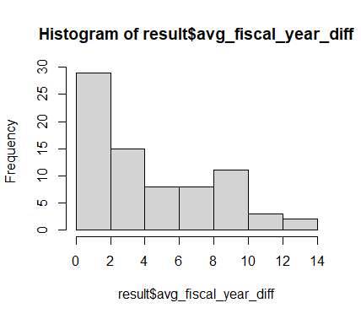

Number of years to next change of status

### Issues (on-premise also is bolded)

|  |  |
| --- | --- |
| Issue | Count |
| legal sale of beer and wine for off-premises consumption only | 345 |
| legal sale of mixed beverages in restaurants by food and beverage certificate holders only | 243 |
| **legal sale of all alcoholic beverages including mixed beverages** | 204 |
| legal sale of all alcoholic beverages for off-premises consumption only | 172 |
| **legal sale of beer and wine** | 56 |
| **legal sale of mixed beverages.** | 12 |
| **legal sale of all alcoholic beverages except mixed beverages** | 6 |
| legal sale of beer for off-premises consumption only | 5 |
| **legal sale of beer** | 3 |
| legal sale of wine by a holder of a winery permit | 3 |
| legal sale of wine for off-premises consumption only | 2 |